Refining Political ideologies for Indian Coalitions
Neo-ideologist

Having had a life span of experimentation with the triad of Socialism, Communism and Capitalism, it is time to distil wisdom out of their shortcomings. Whilst it is certain that no utopian idea will ever work except in the realms of dreams, one cannot stop philosophising about idealist ideologies. For, life and society is what else but dreams that ‘yes, we can’ drive creates and sustains? Not to forget failures and their causative factors, lest we let history repeat itself at high risks.
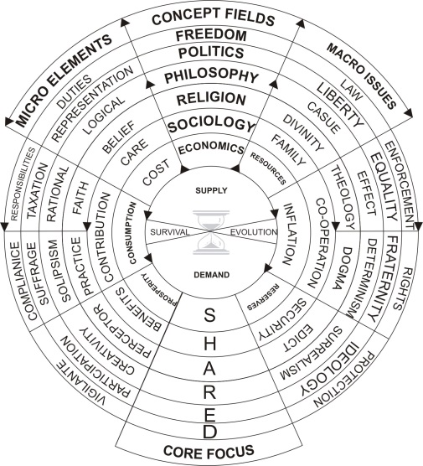
Common vision that drives socio-politics is betterment of life; societies from their natural evolution accepting to live with injection of politics into its strides, accommodating economics too as a dismal empirical science belatedly –albeit with its latent presence in any activity (see: >) productive and creative. No wonder that after three score and ten years the trio are found so immiscible as well as integrated beyond separation. For, it is underlying economics that defines, differentiates, distracts and bedevils the ideologies on exploitation of factors of production and gains ensuing therefrom, to be shared per capita but.

Therefrom, isn’t selfishness the root of all evil? Though nothing belongs to anyone but us all; we are only trustees of passing times! Spiritualists have imbibed so in us, but we would rather grab & possess than share!

As we incise into performance and derived benefits of practices that are preached, let the siblings of liberalism band libertarianism be kept aside as they haven’t had chances to play out long enough for performance review; but yes, they have: pulled the pendulum to left and right of centre, in vain but.

Reasons for failure of well-touted and tried ideologies have been shortcomings in implementation during which their fallacies became glaringly evident due to human follies beyond repair by set up systems; in simple words power, pelf, pride, progenies, perceptions and precipitates thereof.

Capitalism catapulted by nexus between government and the market makers-movers caused its own catastrophe. Communism had to curl back due to its distancing from proletariat – transforming itself as Naxalism- whereas Socialism committed hara-kiri by nepotic thieving/cronyism creating dynastic class in democracies and republics, with despotic/dictatorial tendencies. The liberals though wanting no interference from state and its machineries haven’t been shy in calling for more regulations and rules when the open market systems fail by cornering by the greedy and speculators.

In the Indian context, now that opportunistic coalition is what we will have to live with for quite a while, it is imperative that new choices and alternatives are crystallised, than wasting efforts on dominant ideologies. Pseudo choices aside and manifestos notwithstanding, what we citizens can demand out of governments is effective and efficient corruption free governance indeed, ensuring that the well-provided-for checks and balances in fact are effectively put to work. The successes we have with RTI is timeous; so let us follow up cleaning with sickles, axes, shovels, spades, brooms etc.

Though the objective must be to work with and for the highest common factor for greater common good, divisive lowest common denominator is what the lower satraps and chieftains exploit. Given diversities, divides, inequalities that are inherent, plus the increasing unwillingness for local/regional adjustments/sacrifices for national gains, it is important that plans-progress, outlays, development, prioritisation, employment and trickledown are spread more evenly, fairly and speedily with alacrity.

Jai Jawan-Jai kissan, Garibi hatao; Roti, kapda, Makan; sadak, bijli, paani; India shining ye sub-kuch have all been sloganeered enough, but have come out croppers for the ubiquitous aam aadmi who would prefer cleaner governance so that funds spent on the schemes like MPLAD, NREGA, JRY, NRLM yojanas/schemes (1258 per http://india.gov.in/my-government/schemes) would trickle down and reach them in larger-better portions than the miniscules heretofore. Yes indeed; right to work, food, education, employment, services are on offer on paper without ensuring that they do deliver.

Such failures call for soul searching. Isn’t politics by nature dirty and corrupt? Aren’t humans and we Indians prone and susceptible to short-cuts/by-passes and venal by nature? Have we failed to instil values and responsibilities in us and our children? Has non-violence, non-co-operation, disobedience made us an irresponsible lot? Certainly yes, as can be seen at traffic signals these days! Politicians being a reflected image of voters at large, we need to travel the road of introspection and correction so as to elect better representatives who can be trusted with our mandates. Voting, participation, follow up, demanding performance etc are prescriptive; in other words, political activism. Thence, means, modes, ideologies, methodologies for inclusive developmental progress can be drawn up.

Chasing growth is not a panacea for all ills! Any case, its benefits have to be shared well with the populace. For, lopsided developments and benefits will only sow seeds of trouble for later, unless, fall-backs of social security and the like are set up to mollify the weaklings and non-beneficiaries.

Choices are to broad-base and wide-spread development with Keynesian pump-priming to spread multiplier effect far and wide both vertically in the sectors and horizontally amongst the people. In the low inflation/growth/interest rate developed economies, bestowing benefits directly on citizens to kick start and sustain traction, have been tried out and found somewhat effective. Caveats but; sub-prime mortgage driven housing for one; recession turning to stagflation and not inching up too!

Isn’t India now on such `direct transfers’? Nonetheless, such easy economic transformation agenda does not come without strings attached. Deficit financing for sure, and more! The “what’s in it for us” obstruction of the local and party chiefs -dilemma of coalition politics- need be addressed by prioritising popular demands of the regions and states, not at federal loss but. CSR per Company Act could be the next targeted one to be hijacked by the local power-sharers, with tax exemption too!?

What started off as mid-day meals to get kids to schools and ensure girl child education, has turned out as torrents of freebies for corrupting minds and booth-capturing at massive budget shortfalls. Free sari, blankets, power, subsidised food items, local fast food in canteens, TV, laptops, cycles, scooters, CFL lamps, medicines, health care –dialysis included, free pilgrimage, compensation for crop failures, loans, savings certificates and even hard cash ! These aren’t development per se; nor such efforts. Some like food and crop failure compensation are good, considering farmer suicides. Free mobiles too! Can we fast track voting using mobiles with error free identification? That would be a giant leap, as Estonia has pioneered voting through internet (2005) and mobiles (2011).

Two decades of liberalisation has failed to deliver for the mega populous numbers, developing large fissures between macro and micro levels, though it has been beneficial to few. The much promoted PPP –public Private Partnership – has foundered and floundered as the fourth P of people was not adequately provided for. Large population and high trade deficit with pent up demand appear as ominous signs. But the challenge is to convert them to opportunities to serve huge numbers waiting to be tapped as upwardly mobile customers. Revised socialism with watered down capitalism and revisioned communism may perhaps be the masla-kichdi philo-ideology that suits Indian palettes.

As such, a right admixture of socio-politico-economic ideologies suitable to India need be formulated so that it can be effectively, efficiently and successfully implemented taking all into confidence. Lead, Follow or Move is the dictum. Direction and speed are critical. Perform or perish is the mandate.

Be forewarned that time and patience are running out. This is not the time to play sectarian politics; for, secularism is our underlying strength. Deficits in trust, leadership and everything else is obvious. The fervent hope - with the now turning-18 new voters and the youth holding majority- is that a new crop of young driven leaders –bereft of dynastic hang overs-will emerge to take our nation forward.

